# Conflict Scenario

## **Review**

### Interpersonal Conflict Management Styles

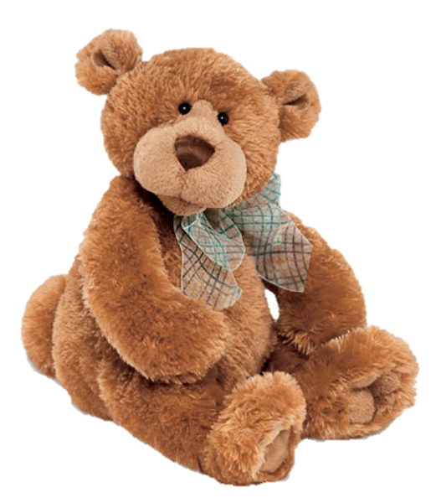

[CC 2.0 BY Matthew](https://www.flickr.com/photos/falcon1961/3304306800/)



[CC SA 3.0 Unported BY Jonathan Zander](https://en.wikipedia.org/wiki/File:Florida_Box_Turtle_Digon3.jpg)



[CC 3.0 BY Superawesomevectors](https://superawesomevectors.deviantart.com/art/Shark-Cartoon-Free-Vector-Illustration-643399222)



[CC0](https://pixabay.com/en/urban-lost-hiding-afraid-1002149/)

Low to High Concern for Other

Concern for Self

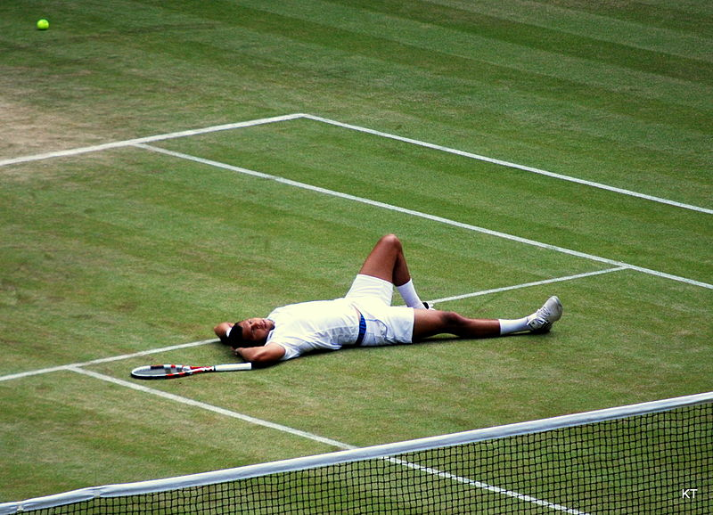

CC SA 2.0 Generic BY [Carine06 from UK](https://commons.wikimedia.org/wiki/File:Flickr_-_Carine06_-_%22I_give_up.%22.jpg)



CC 2.0 BY [Zabara Alexander](https://www.flickr.com/photos/zabara_tango/6955720271)

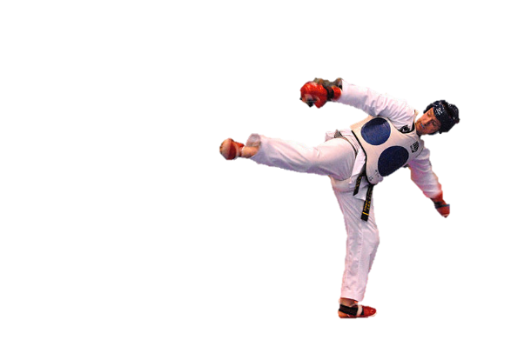

[CC0](https://commons.wikimedia.org/wiki/File:US_Army_53525_Soldiers_compete_in_Tae_Kwon_Do_tournament_for_Warrior_Country_level.jpg)

### **Interpersonal Conflict Resolution**

The following diagram shows a process that can be followed when trying to resolve interpersonal conflict.

### Listening

A considerable proportion of our communication involves listening, yet little attention is devoted to improving listening. HURIER is an acronym for tips that can be used to improve listening.

### “I” Phrases for Conflict Resolution

The “I” phrase is used during conflict resolutions to avoid attacking others. Open the conversation with a statement in first person, passive voice: “I feel … when … because … I would like …”

Adapted from (Dwyer 2012, p. 40)

## **Student Name and ID:** Hardik Dhorajiya (12194991)

## **Student Name and ID:** Akash Barai (12196935)

## **Scenario**

Find a partner. Read the scenario below. Choose one partner to be Joe Bloggs, and the other to be Jane Doe. Together, answer the following to help prepare you for the role play.

## **Scenario: Joe did not complete a task by the deadline**

Joe and Jane are working on a report that is due today. Joe was assigned the task of writing the executive summary. Unfortunately, Joe has not completed the task.

What is the most appropriate conflict management strategy for Jane to use in this situation? (Choose one)

Compete/Force

Compromise

Avoid/Withdraw

Collaborate/Confront

Accommodate/Smooth

Why did you choose the above conflict management strategy?

>>We chose it because if Jane and Joe collaborate with each other they can make perfect summary without wasting time. They will able to make a mutual understand to solve the problem which helps to improve the productivity.

### **Listen and Understand**

How could Jane start the conversation?

>>Jane can start conversation like – “I would like to discuss something about our executive summary. Let’s discuss about our task and let’s work together.

Describe the purpose of the discussion. Describe the conflict. What questions could >>Jane ask to determine Joe’s perspective of the situation?

If they discuss they can find a solution to complete the task on time and their relationship will be remain same. Because by this discussion Jane will understand the real problem of Joe’s inability.

-The conflict is Joe did not completed his task on time so that is why conflict happened between Joe and Jane.

Write sentences that features the “I” phrase, such as in the example below:

“I feel *[your feeling]* when *[their behaviour]* because *[effects on you]*. I would like *[alternative behaviour]*”.

>>I feel your anxiety because I did not completed our task on time. I could inform about my situation before deadline of the task. I apologize for my kind behaviour.

Invent a reason why Joe did not complete the executive summary by the deadline.

>>Joe did not completed their task because a week ago he lifted 70Kg and he got cramped in his back. And he was bed in rest till deadline of given task. As a result he did not completed given task.

How could Jane paraphrase Joe’s reason for missing the deadline to ensure that she understands Joe’s perspective?

>>Jane can feel the situation of Joe. When Joe was in bedrest then Jane can say to Joe that – “I can understand this situation”.

### **Empathise**

Now that Jane understands Joe’s perspective, how could Jane empathise with Joe? Write a response that shows that Jane identifies with Joe’s emotions.

>>Jane can say that it was not intentionally or not your fault, you were in a real trouble that is why it happened.

### **Apologise**

Include an apology if it is appropriate.

>>Joe has to apologize to Jane as he did not completed the task because of me you will also get in trouble.

### **Offer Solution**

What question could Jane ask to help build Joe’s involvement with potential solutions?

>>Jane asked to Joe for collaborate with her to complete the task and share their ideas and research work done by Joe.

Come up with a way for Jane and Joe to settle on a solution.

>>Jane and Joe can collaborate with each other and complete the remaining task within time.

### **Resolution**

How could Jane resolve the conflict? Jane needs to ensure that Joe agrees. Write a response that outlines appreciation for the solution.

>>Jane can ask to Joe that he should collaborate with her to complete task and resolve the conflict by suggested solutions of Joe.

### **Reconciliation**

How could Joe reconcile the relationship and let Jane know that she is important to him?

>>Joe should definitely collaborate and apologise to let her know that she is important to him.

How can Jane let Joe know she is listening while Joe is talking?

>>Jane could do facial expressions and appreciation after each topic and also she could give him consolation.

What could Jane do if Joe started to withdraw from the conflict at any stage?

>>If Joe wants withdraw himself from the conflict at any stage then Jane has to finish the unfinished summary as it should be completed because it can create another issue within group.